

Document Title

Quorum Network Resources Ltd

Document SubHeading

Author

Date

Table of Contents

1. Overview 3

1.1. Introduction 3

# Overview

## Introduction

# Data Transformation

## Import multiple tables from a single source file

**Task:** Import multiple tables from a single excel source file.

1. **GetData** > from Excel **Path**\**Power Query\Demos\Loading Data\Data\VanArsdel_Actuals.xlsx**

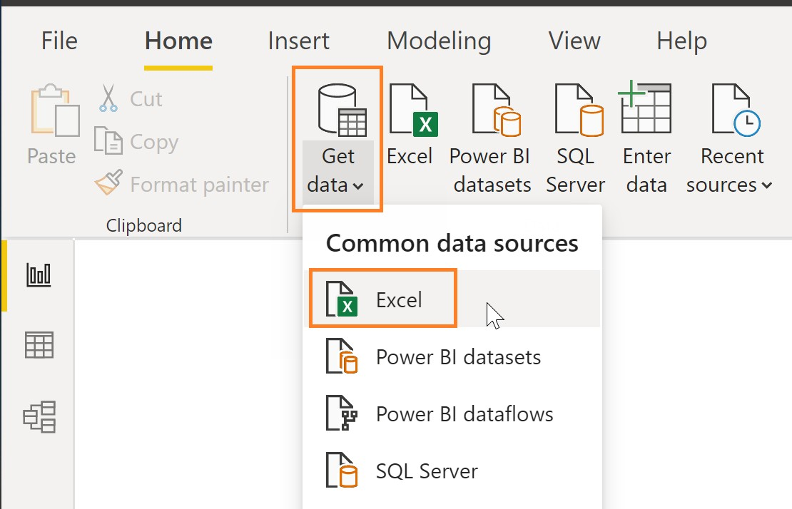

1. Select the following Tables (All but CustomerDim):

* **CampaignDim**
* **GeoDim**
* **ProductDim**
* **DateDim**
* **Sales**

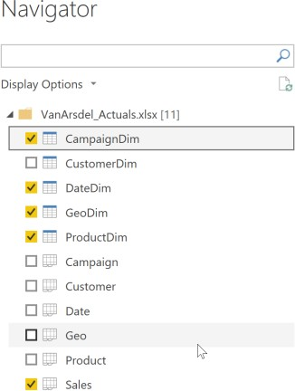

After tables are loaded click on **Transform Data**

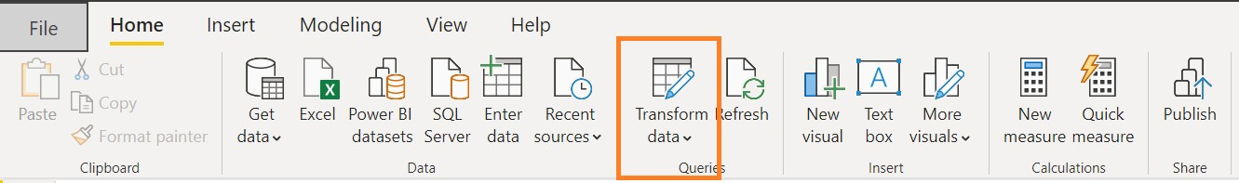

In **GeoDim**, change the **Zip** data type to **Text**

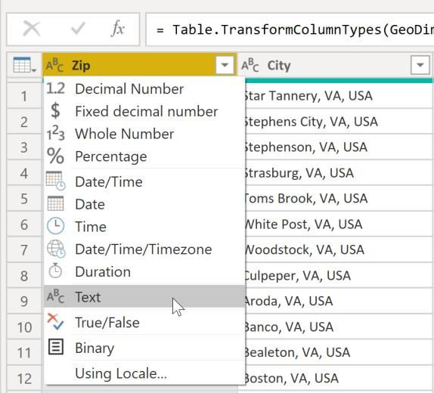

## Create lab parameters

**Task:** Create new parameters

1. Click on Transform Data
2. From the Home Ribbon > Manage Parameters

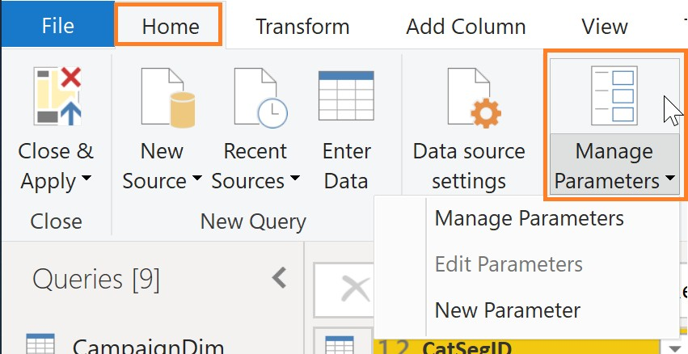

1. Create a new **Parameter**
   1. Parameter Name: **Path**
   2. Type: **Text**
   3. Current Value = **C:\Power BI_Adv_M\**

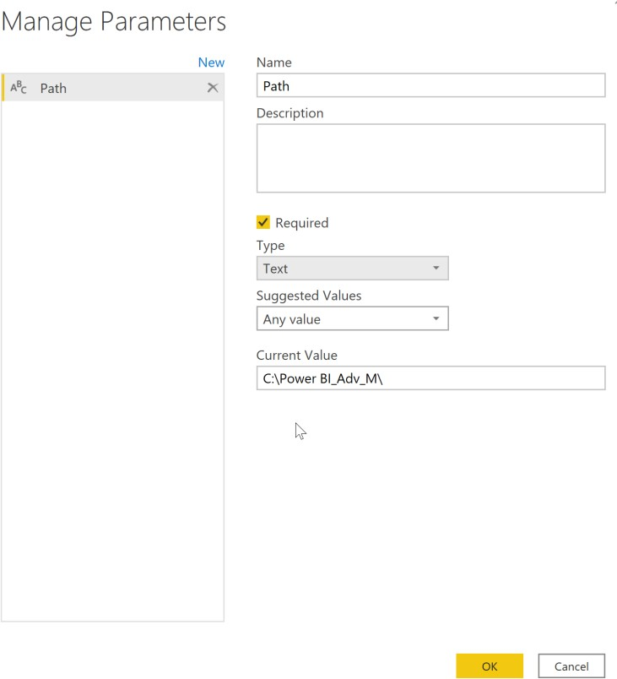

1. Create a new **Parameter**
   1. Parameter Name: **Actuals_File**
   2. Type: **Text**
   3. Current Value = **VanArsdel_Actuals.xlsx**

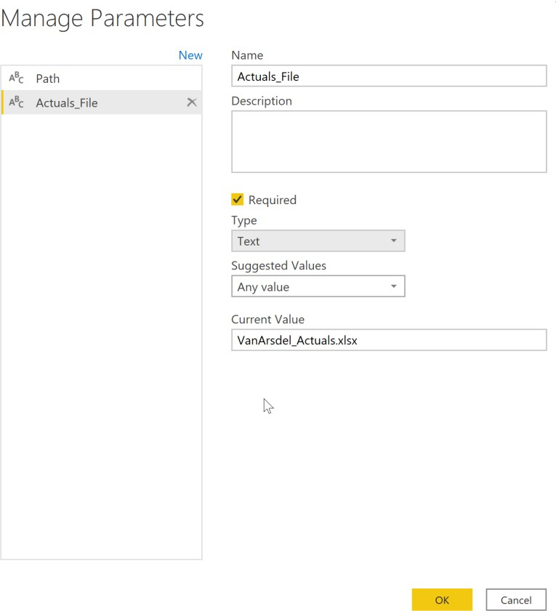

1. Create a new **Parameter**
   1. Parameter Name: **Budget_File**
   2. Type: **Text**
   3. Current Value = **VanArsdel_Budget.csv**

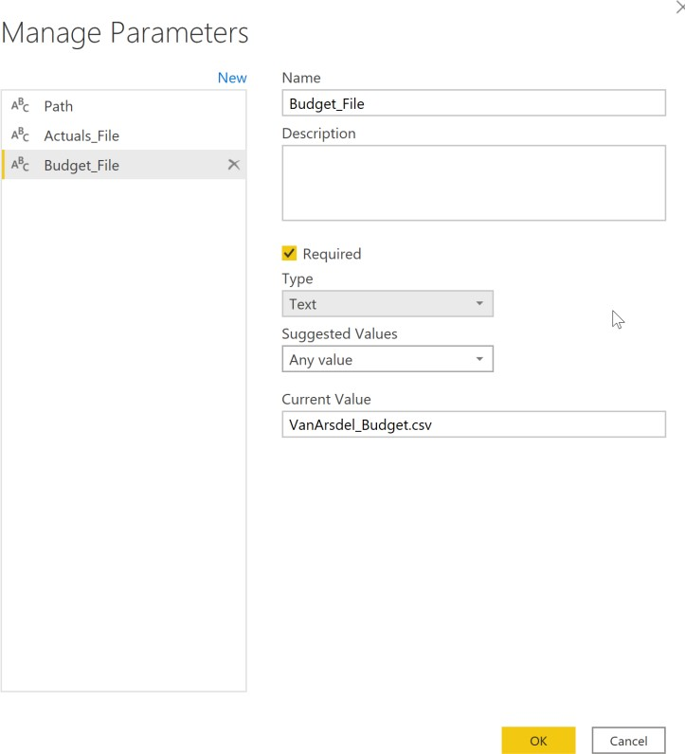

1. Update the text files to ensure the parameter names are consistent.
2. Create grouping for the queries.

## Create CatSegDim

**Task:** Create a dimension using Category and Segment attributes from the Product dimension

1. From the **View** ribbon check **“Always Allow”**

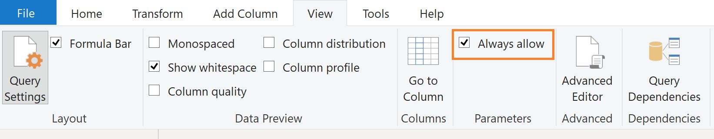

1. **Duplicate** the **ProductDim** query

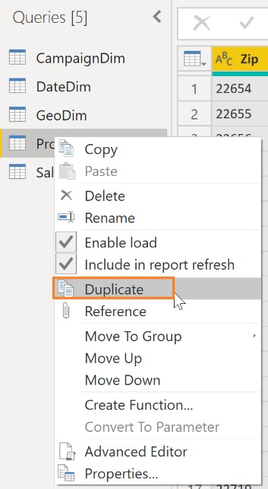

1. Highlight **Category** and **Segment**, and **Remove other columns**

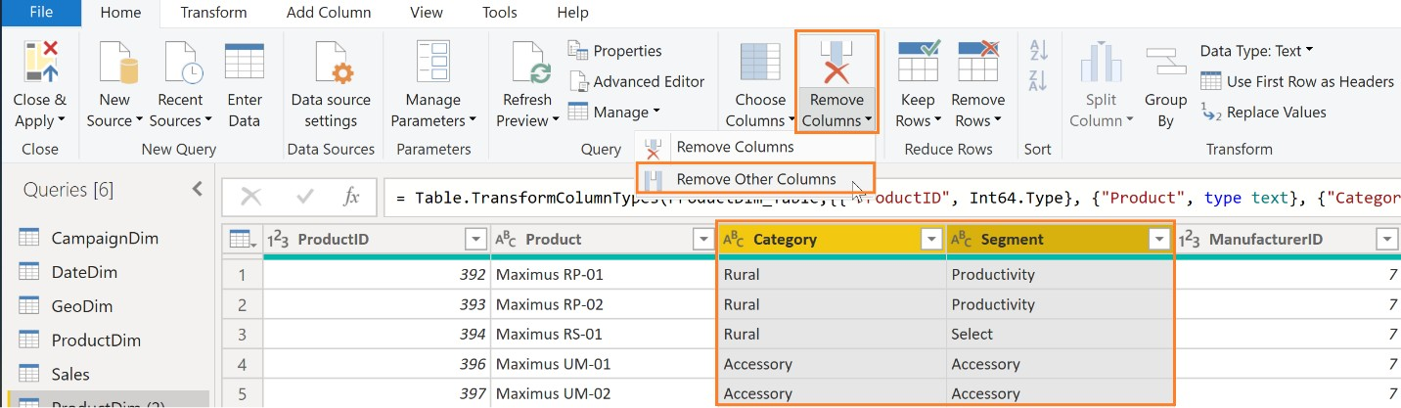

1. Highlight **Category** and **Segment**, and **Remove Duplicates**

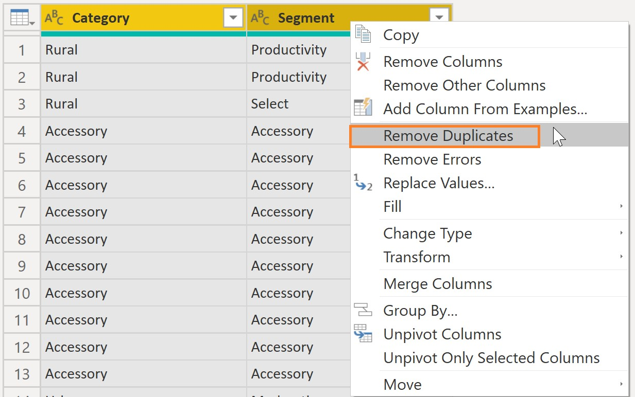

1. **Add Column**> Add **Index** Column starting at 1, with column name **CatSegID**

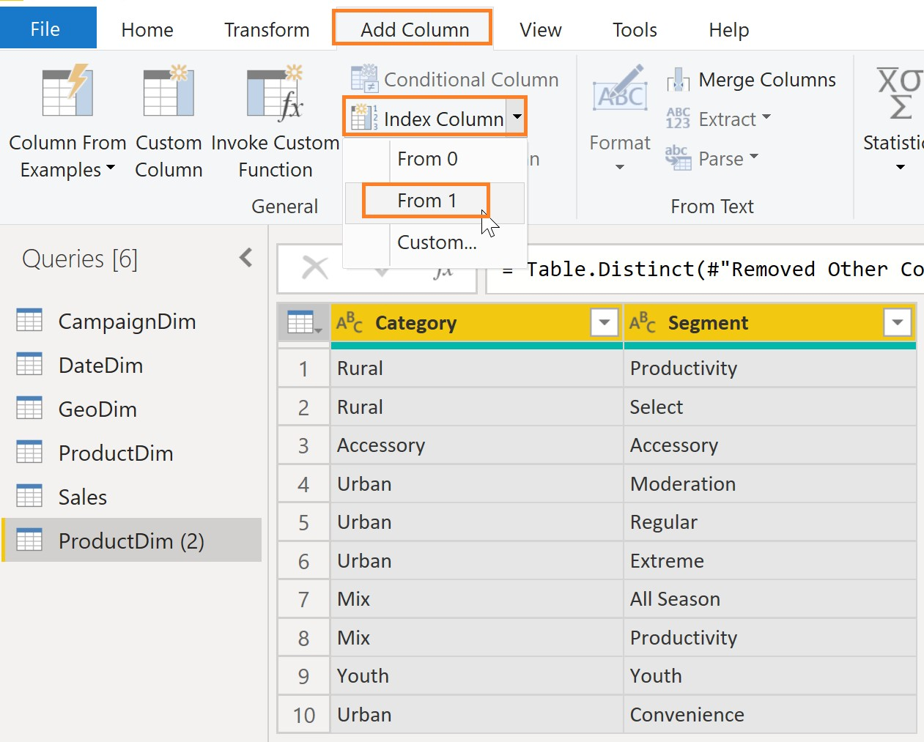

1. Reorder Columns: **CatSegID**, **Category**, **Segment**

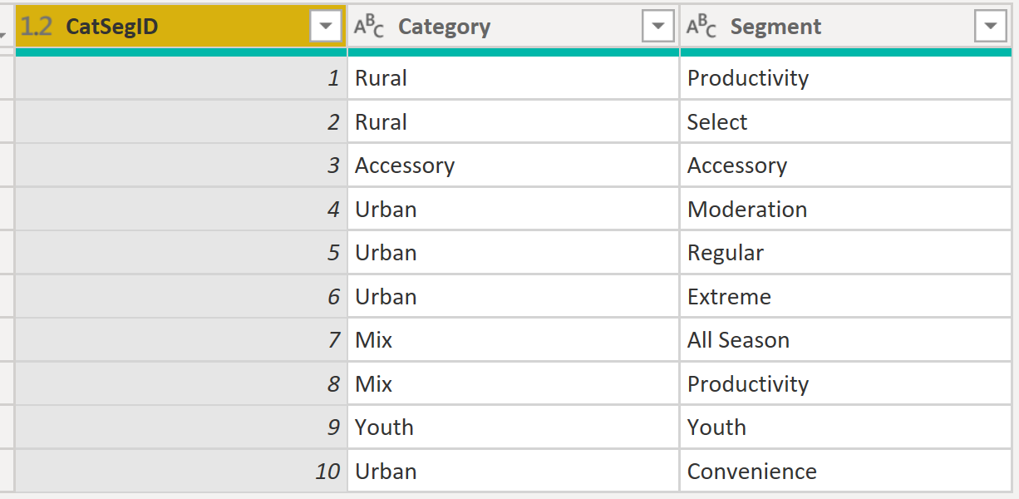

1. Rename the query **“CatSegDim”**

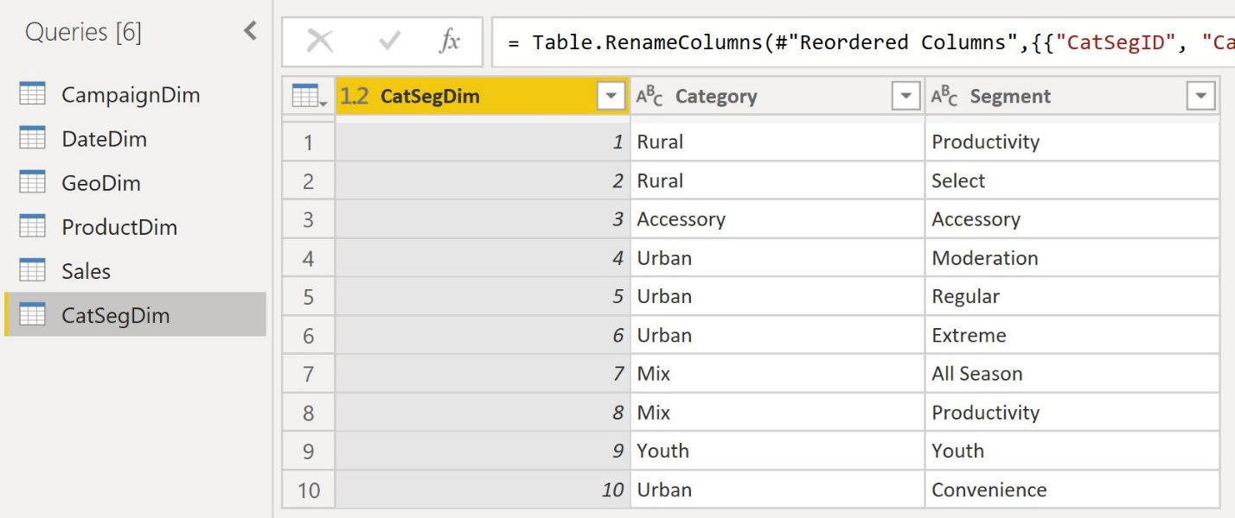

## Update Product dimension

Task: Update the Product dimension

1. Select the **ProductDim** query
2. From **Home** Ribbon > **Merge Queries** > Select **CatSegDim**
   1. From **ProductDim**, highlight **Category** and **Segment**
   2. From **CatSegDim**, highlight **Category** and **Segment**
   3. Note the Join Kinds available, and leave **Left Outer**

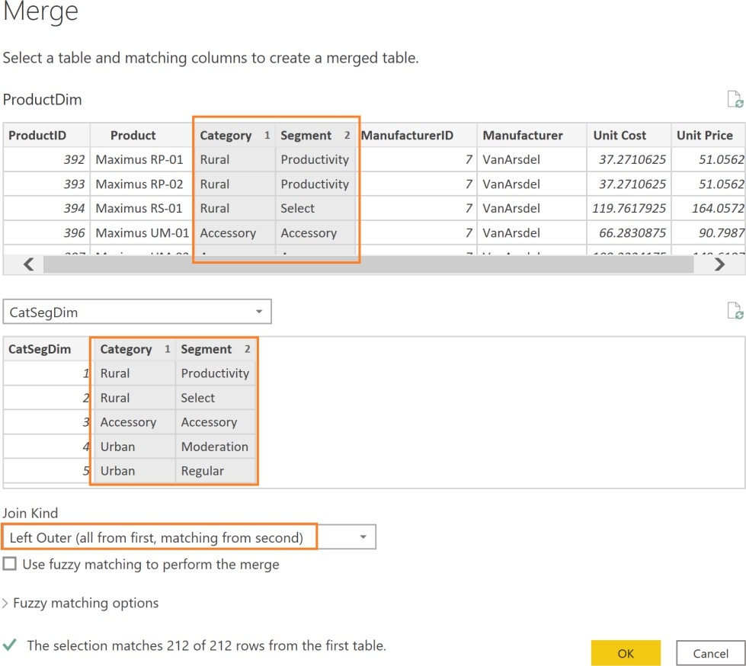

1. Expand the **NewColumn** > Select **CatSegID** and deselect “**Use Original column name as prefix**”
2. 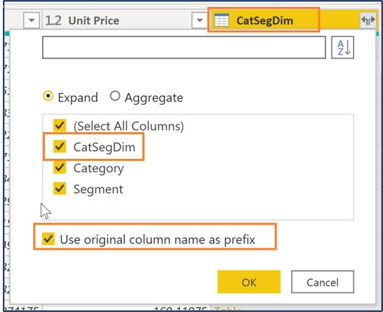
3. Remove columns: **Manufacturer ID**,and **Manufacturer**.
   1. There is only one manufacturer name and one manufacturer ID, so we don’t need this information!
4. Reorder columns: **ProductID, Product, CatSegID, Unit Price, Unit Cost, Category, Segment**

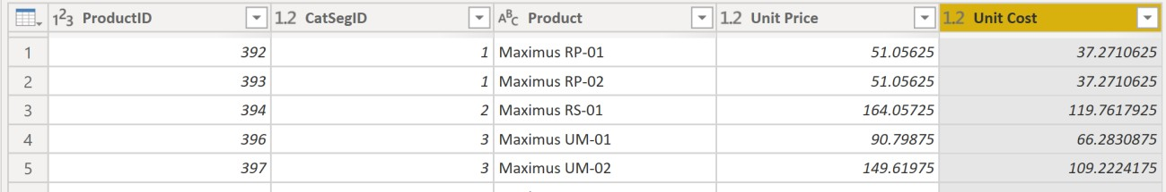

## Create Customer dimension

Task: Create a Customer dimension

The estimated time to complete this lab is 30 minutes.

Use Recent Sources to get CustomerDim from Excel

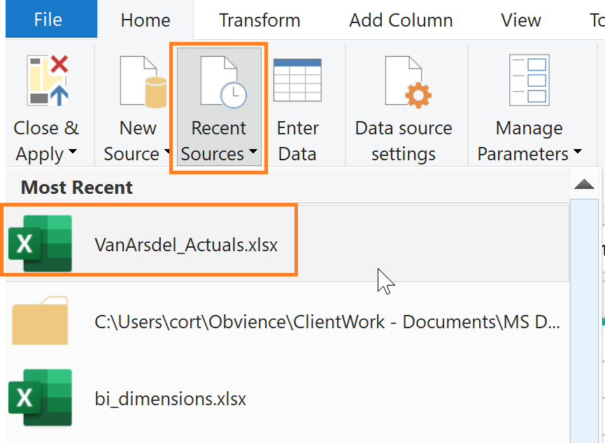

Change the ZipCode column data type to Text

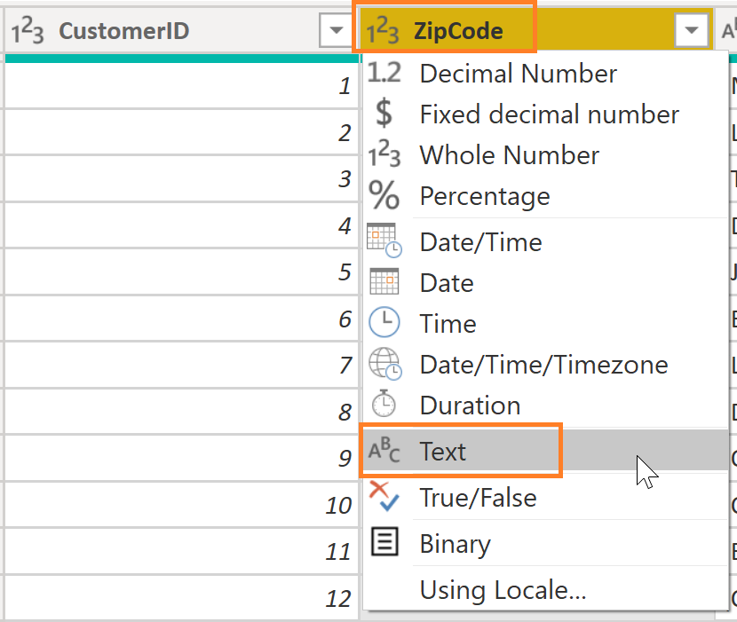

Split Email Name by Delimiter Custom“: “ (colon space)

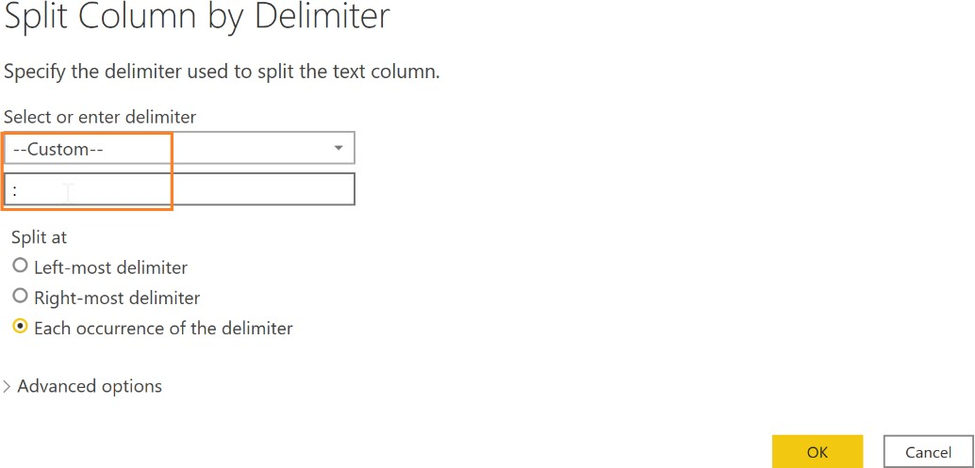

Add Column to find Text.PositionOf() the comma

Add Column > Custom Column

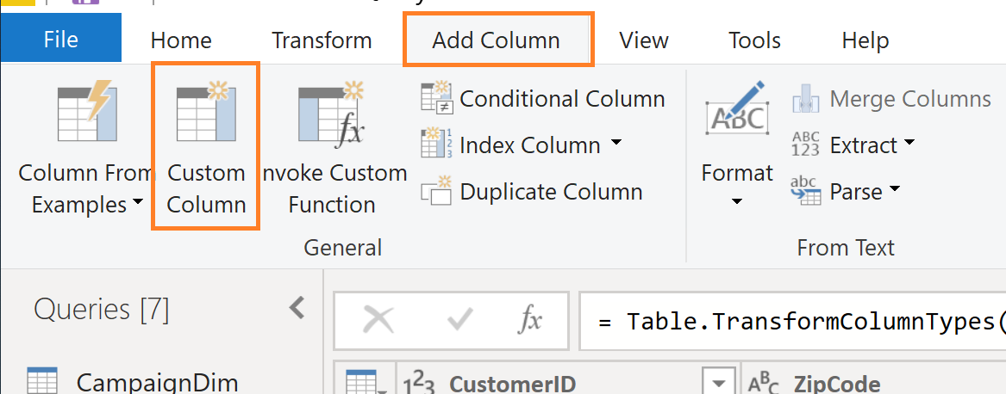

Name = “Separator”

Formula = Text.PositionOf([Email Name.2],",")

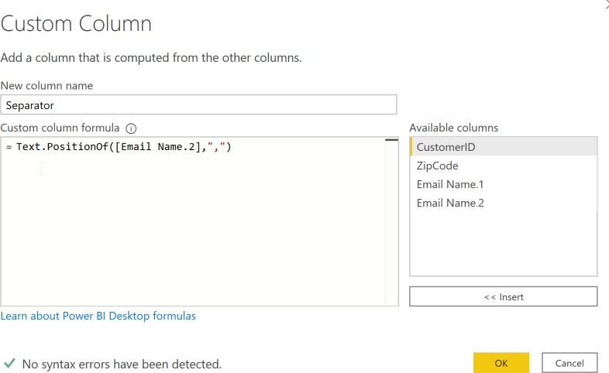

Use position of comma to split Last Name and First Name

Add Columns for First Name, Last Name and Full Name

Last Name = Text.Start([Email Name.2], [Separator])

First Name = Text.Range([Email Name.2],[Separator]+2)

Full Name = [First Name] & " " & [Last Name]

Remove Separator column

Lab 2d: Create Budget Fact table

Task: Create Budget fact table

The estimated time to complete this lab is 45 minutes.

Import CSV document “C:/Power BI Adv_M/VanArsdel_Budget.csv”

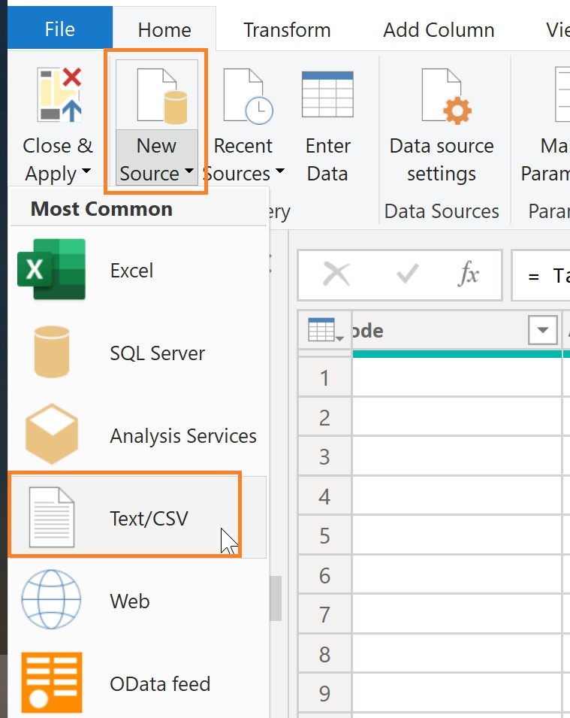

Rename query from VanArsdel_Budget to BudgetFact_Data

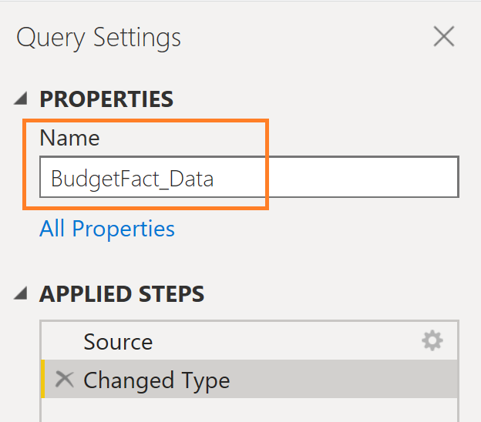

Remove Rows > Remove Top Rows, enter 3 (to remove the first 3 rows)

Duplicate query BudgetFact_Data rename to “BudgetFact”

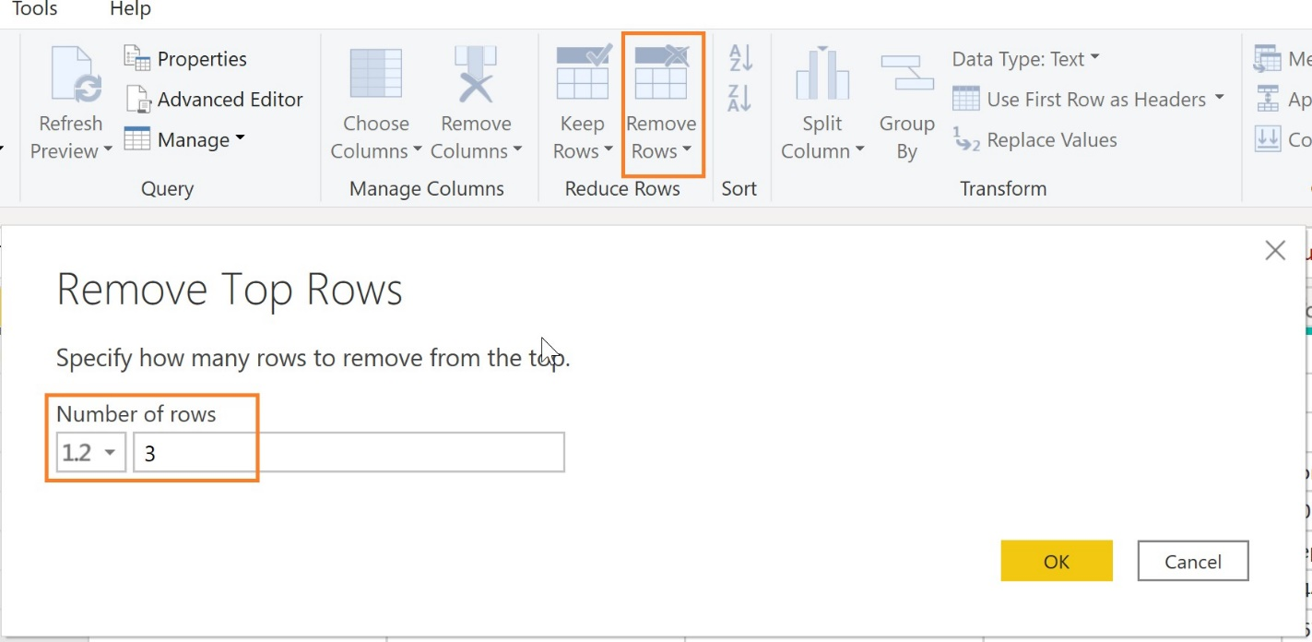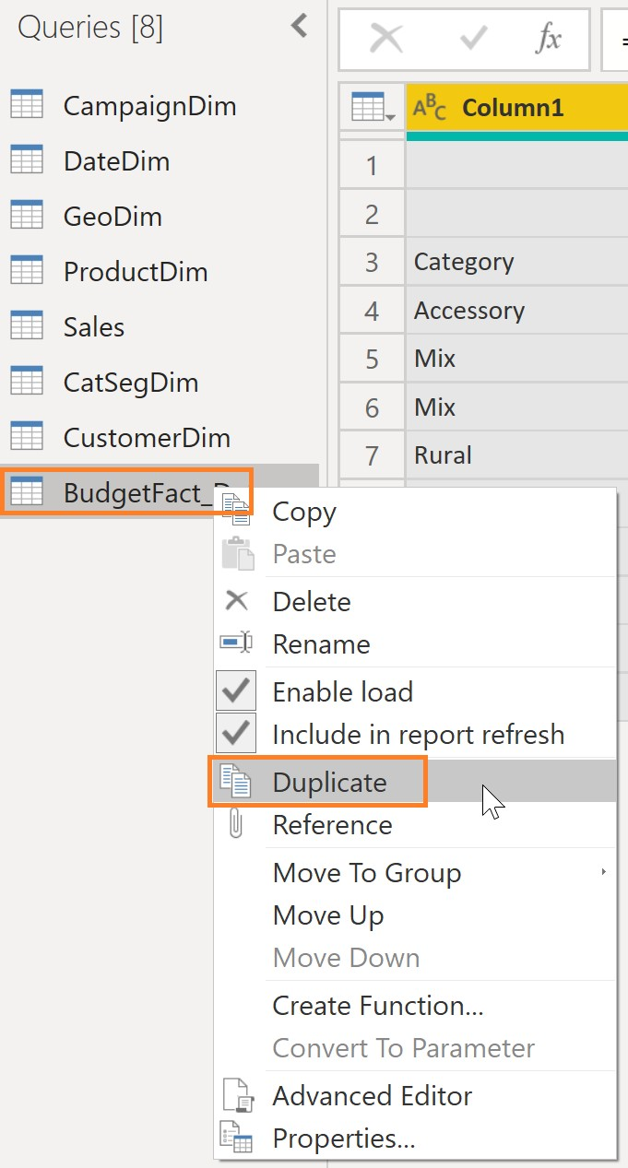

Keep Rows > Keep Top Rows, enter 3 (to keep the first three rows)

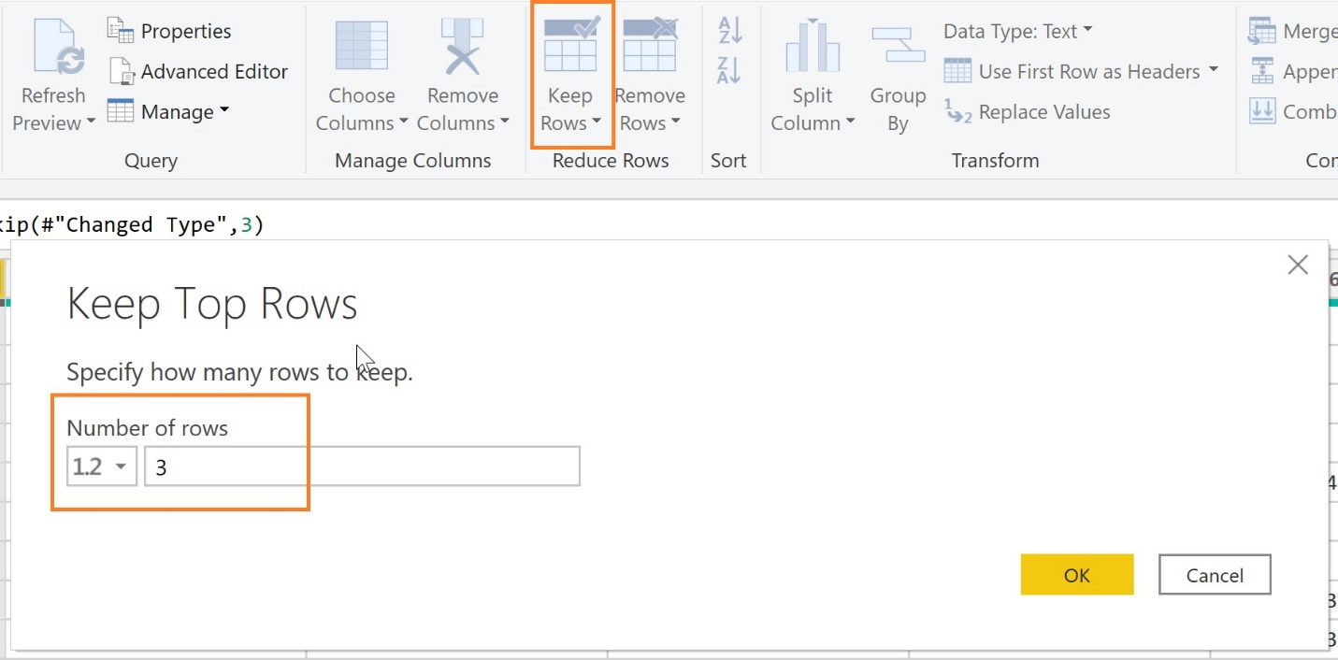

Transform> Transpose

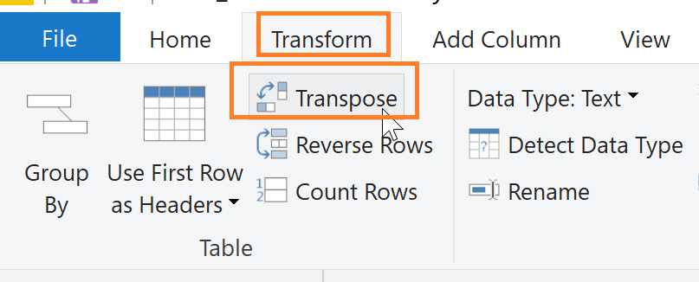

Add Column to combine month and year into a date a

Add Column > Custom Column

Name = “Budget Month”

Formula = Date.From ([Column3] & [Column2])

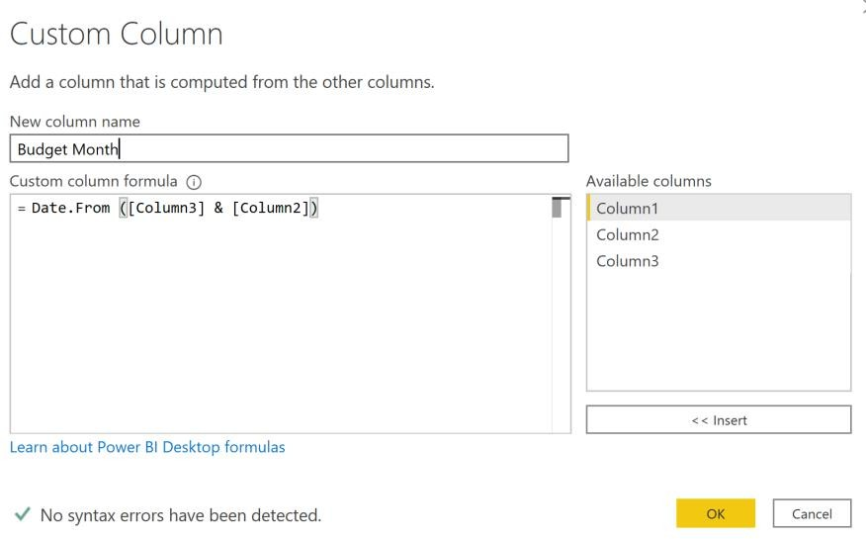

Add Column to combine Month and Scenario

Add Column > Custom Column

Name = “FullyCombinedHeader”

Formula = if Text.Length([Column3]) > 3 then [Column3] else [Column1] & "~" & Date.ToText([Budget Month], "M/D/YYYY")

Hint: Day did not come through correctly, as it is case sensitive. Update to “MM/dd/yy”

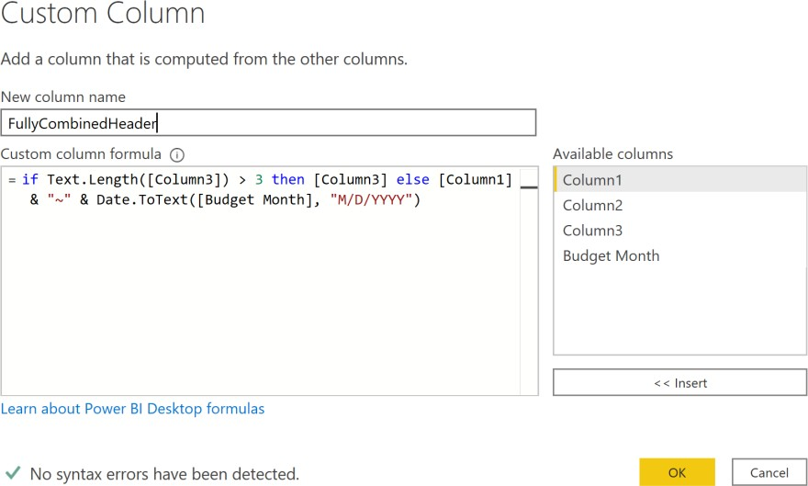

Remove all columns except for FullyCombinedHeader

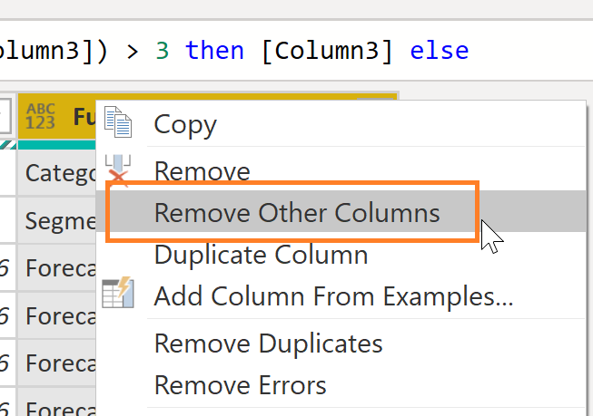

Transform> Transpose to transpose back to wide

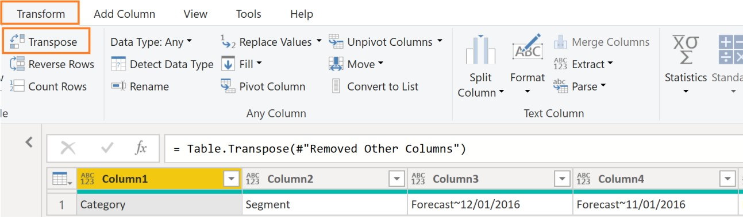

Append query BudgetFact_Data

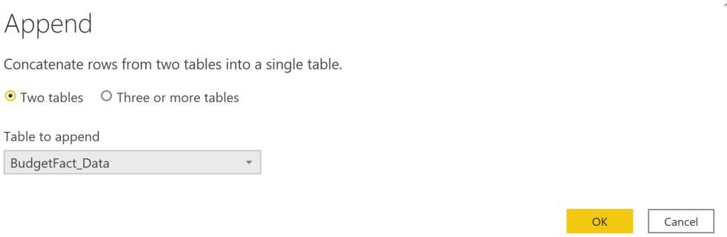

Use First Row as Header to promote the newly fixed header row

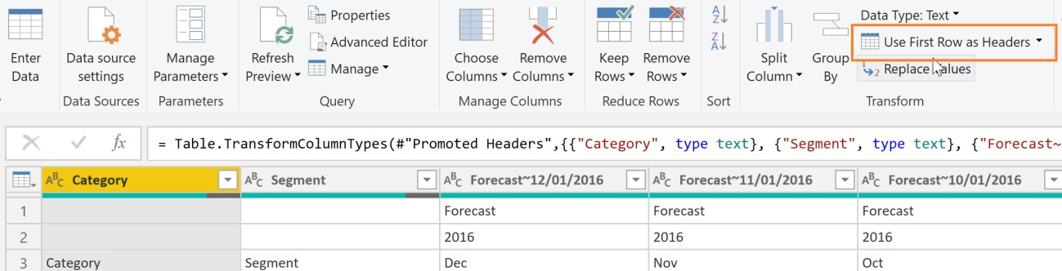

Remove Rows > Remove Top Rows, enter 3 (to remove the first 3 rows – the old header rows)

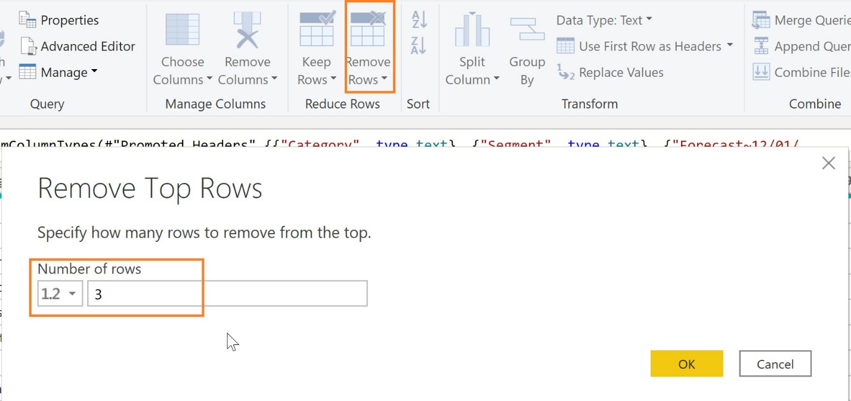

Highlight Category and Segment and Transform> Unpivot Other Columns

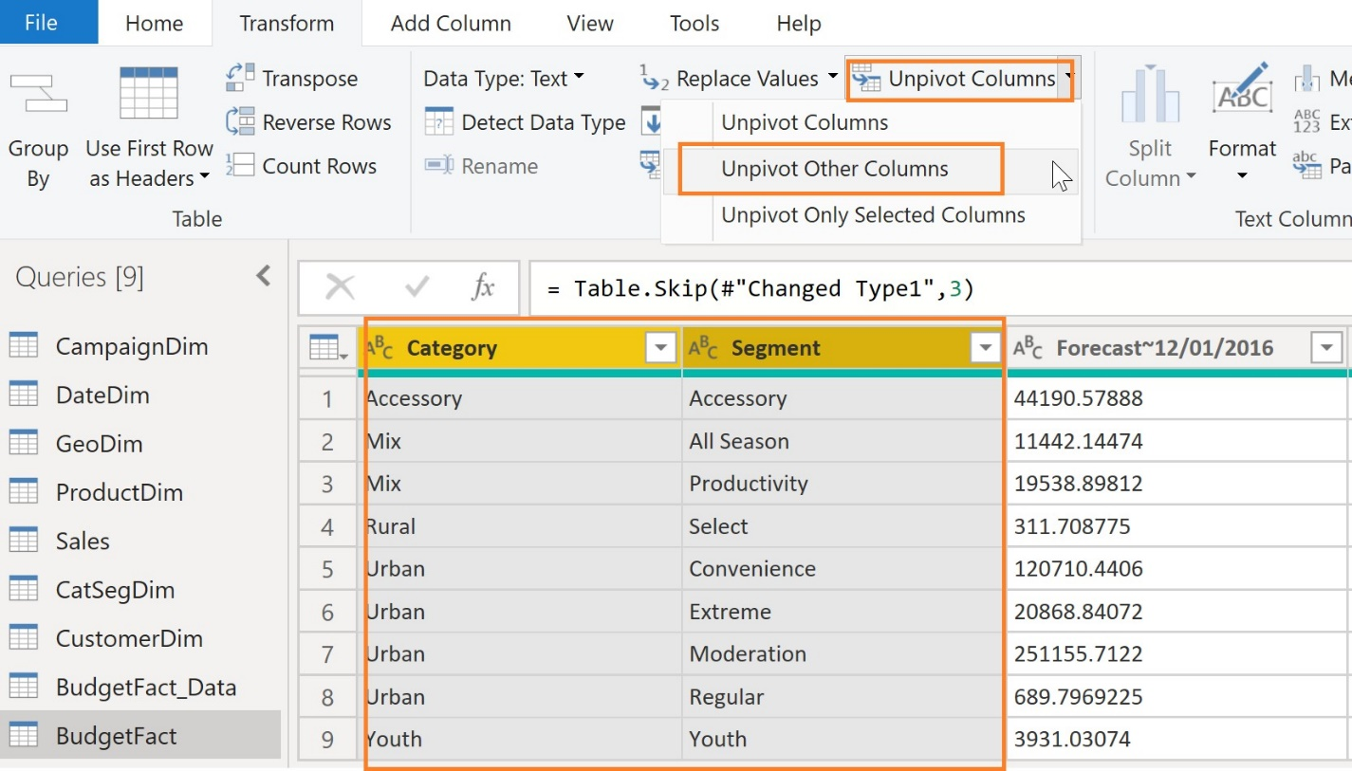

Highlight Attribute and navigate to Home > Split Column > By Delimiter > “~”

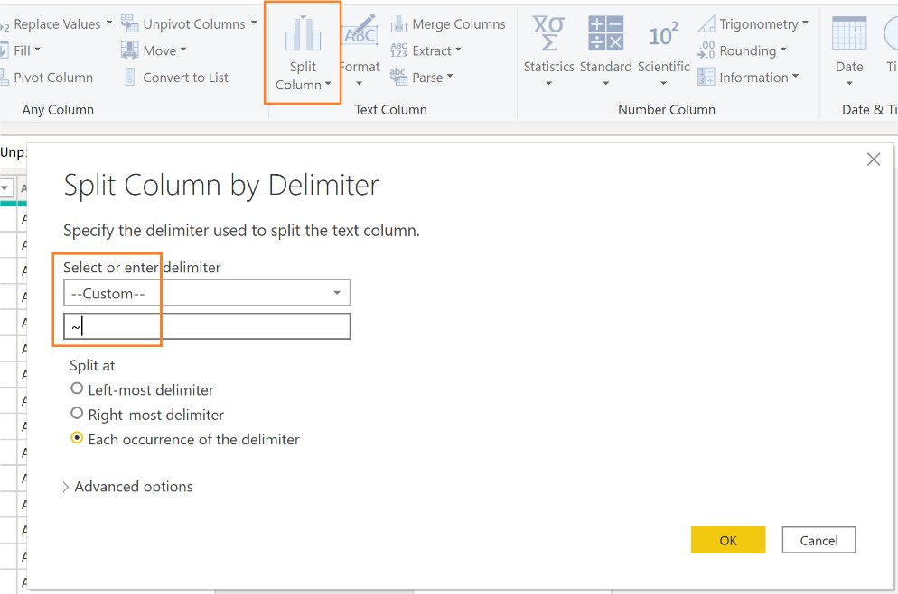

Rename: Attribute.1 = “Scenario”, Attribute.2 = “Date”, Value = “Budget Amount”

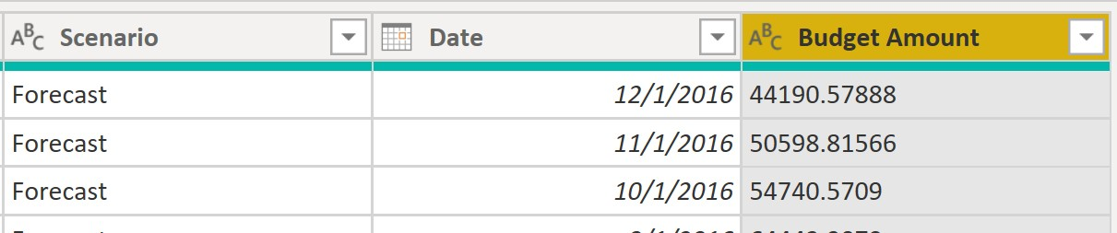

Change the Data Types: Budget Amount = Fixed Decimal, Date = Date

Home > Merge Queries > Select CatSegDim

a) From the CatSegDim highlight both Category and Segment

b) Go back up to BudgetFact, highlight both Category and Segment

c) Show the Join Kinds available, and leave “Left Outer”

d) Expand NewColumn > Select “CatSegID” and deselect “Use Original column name as prefix”

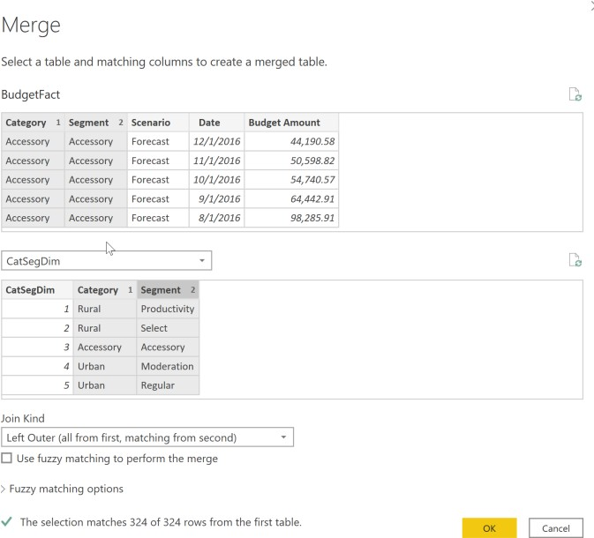

Remove: Category, Segment

Reorder: CatSegID,Scenario, Date, Budget Amount

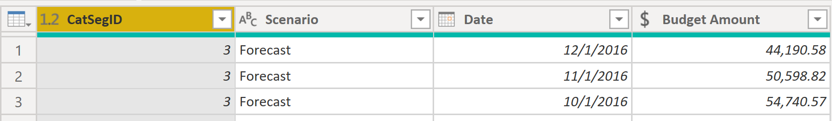

Disable the load of BudgetFact_Data

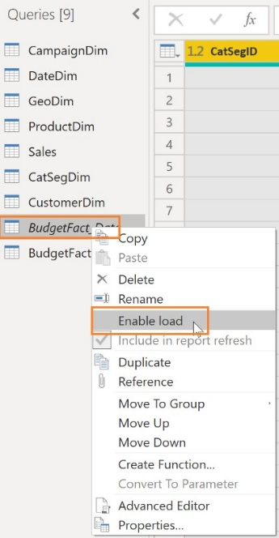

Lab 3: Create relationships between tables

Task: Create relationships between multiple tables.

The estimated time to complete this lab is 20 minutes.

Navigate to model view.

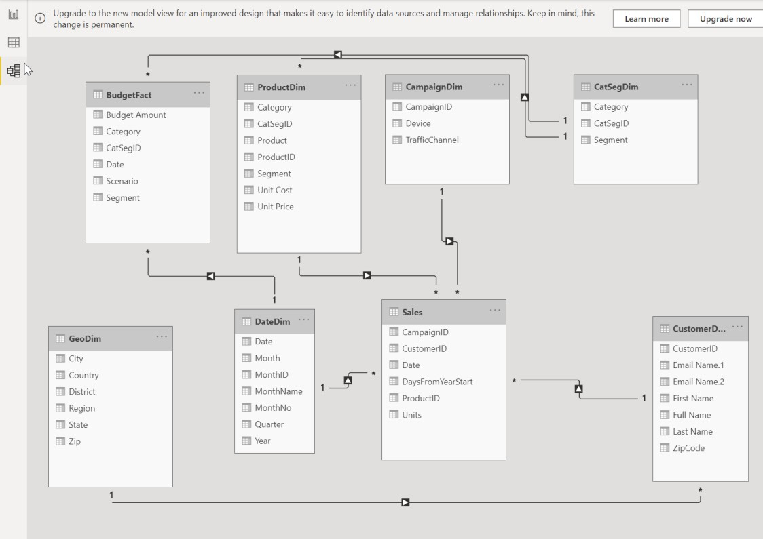

Drag a relationship line between Date field from Sales table to Date field from DateDim table, create the same relationship between the Date table and the BudgetFact table

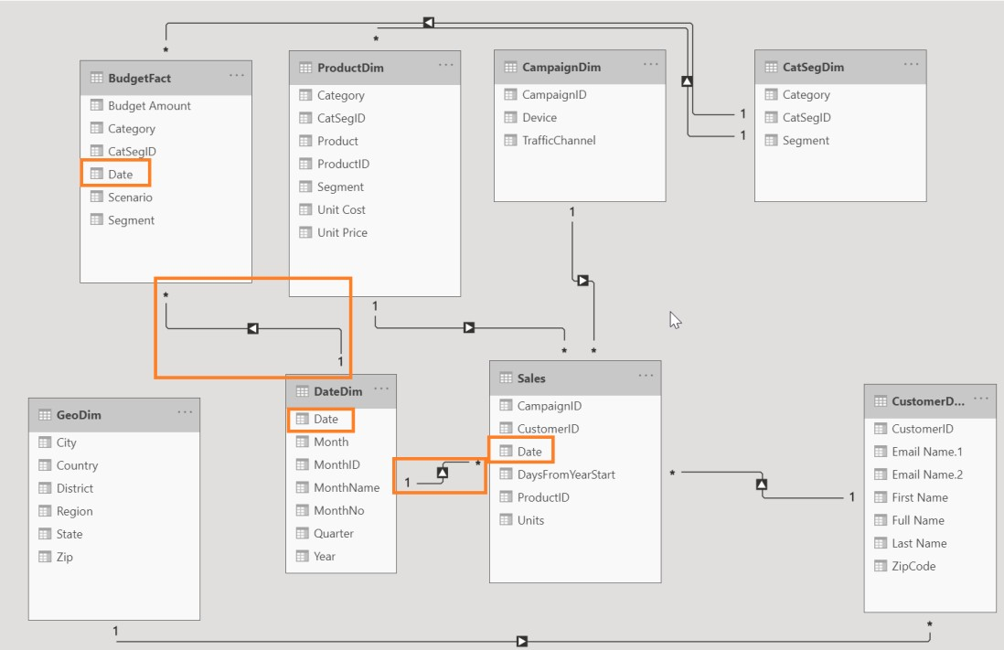

Lab 4a: Create dynamic path to excel source file

Task: Create a dynamic path to the excel source file

The estimated time to complete this lab is 15 minutes.

Create a new blank query

a) Query Name: “Actuals_Path”

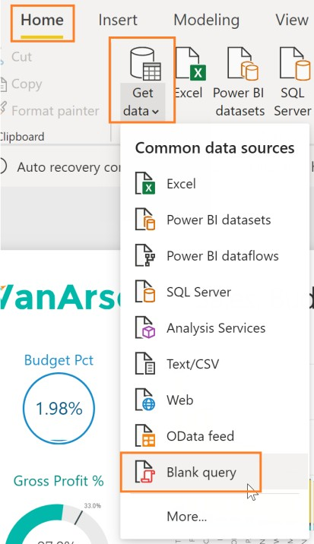

b) Copy in text from the file Actuals_Path.txt

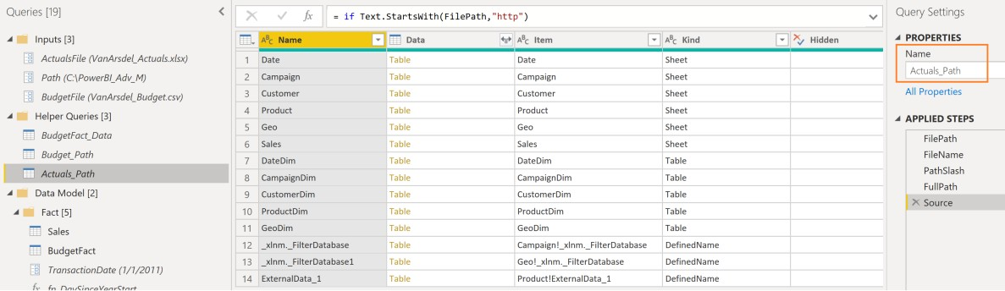

Update Source Applied Step to use Resolved Path = “Actuals_Path” to the following Queries: • CampaignDim • CustomerDim • ProductDim • CatSegDim • Date • GeoDim • Sales

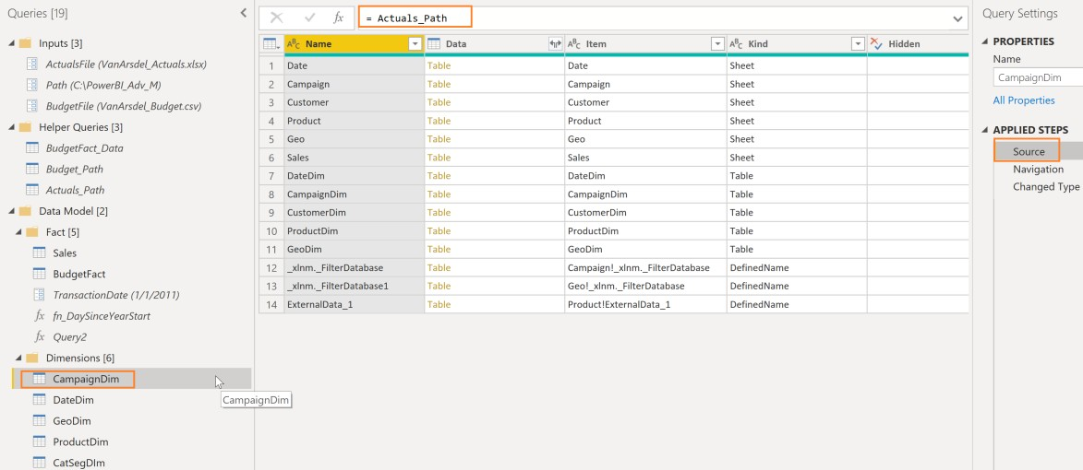

Lab 4b: Create dynamic path to csv source file

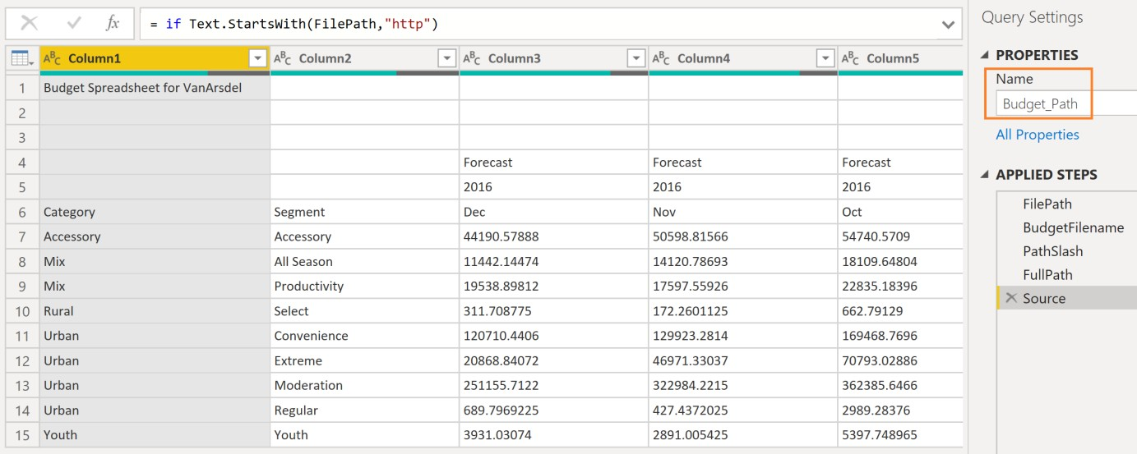

Task: Create a dynamic path to csv source file

The estimated time to complete this lab is 15 minutes.

Create a new blank query a) Query Name: “Budget_Path”



Copy in text from Budget_Path.txt

UpdateSource Applied Step to use ResolvedBudgetPath = “Budget_Path” to the following Queries: • BudgetFact • BudgetFact_Data

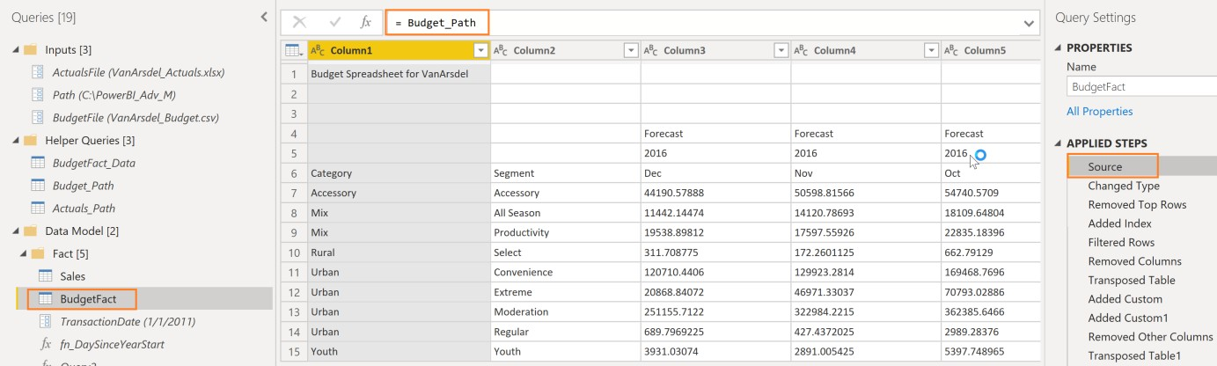

Lab 4c: Create a custom function

Task: Create a custom function

The estimated time to complete this lab is 15 minutes.

Create a new blank query



Query Name: “fn_DaySinceYearStart”

In Advanced Editor copy in text from Number_Days.txt

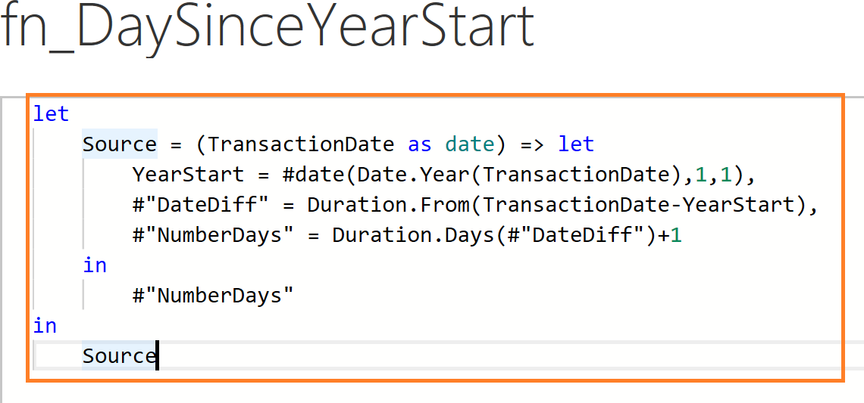

Create a new Parameter

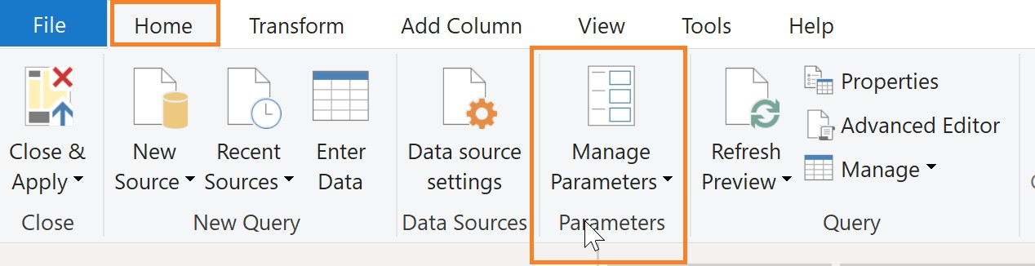

Parameter Name: TransactionDate

Type: Date

Current Value = 1/1/2011

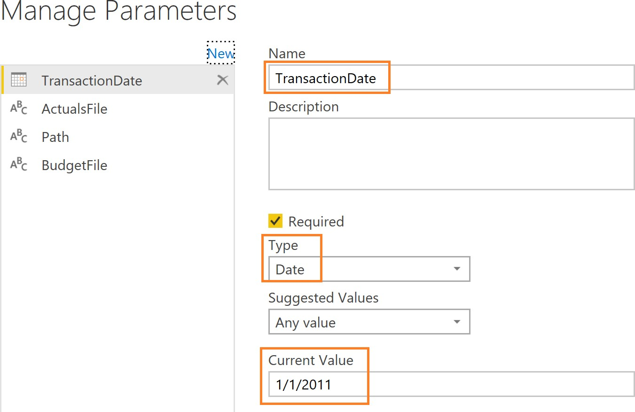

Update Sales query

Add Column -> Invoke Custom Function

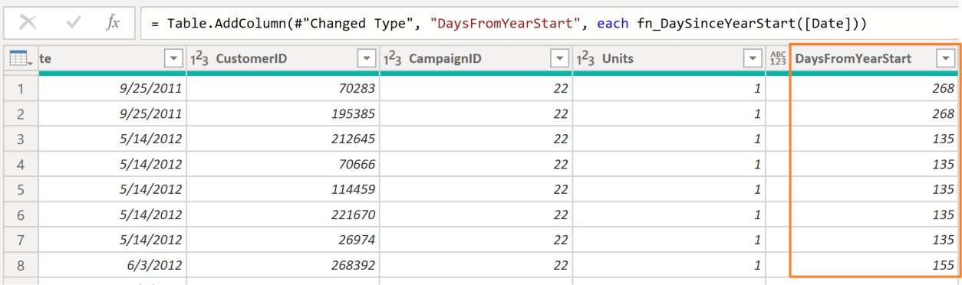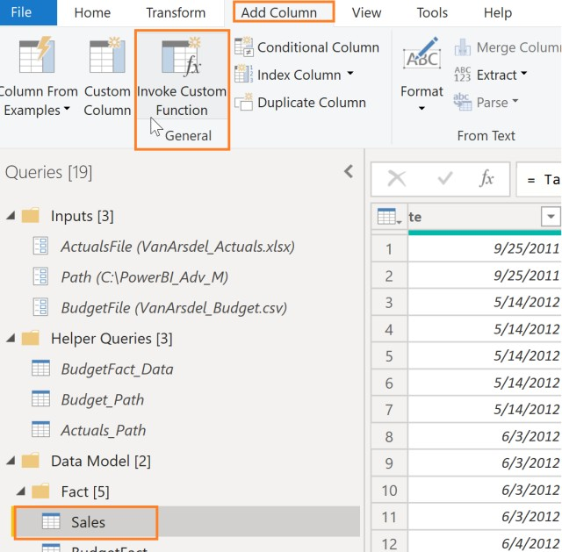

New Column Name: DaysFromYearStart

Function query: fn_DaySinceYearStart

Transaction Date = Select current date from calendar

Click Close & Apply to exit Power Query

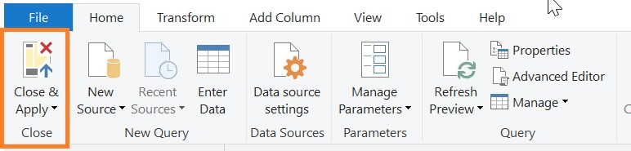

Close and Save the pbi file.

Lab 5: Create new measures and columns

Tasks: You will create a new measure for Total Units Sold, a new calculated column that combines Product Category and Campaign Traffic together, and create visualizations to test the new measure and column

Task 1. Create Total Units Sold measure

The estimated time to complete this lab is 30 minutes.

Select Sales Table. From the ribbon select Modeling -> New Measure

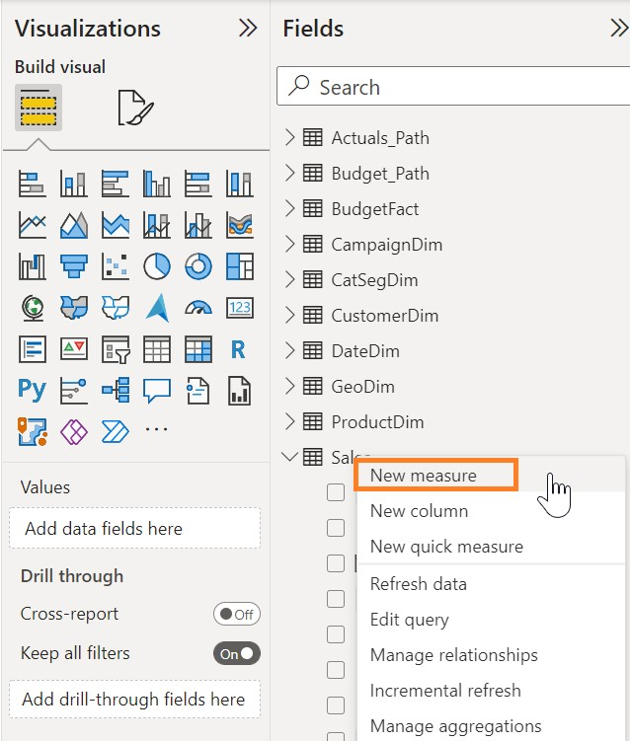

In the formula bar enter:

Total Units Sold = SUM(Sales[Units])

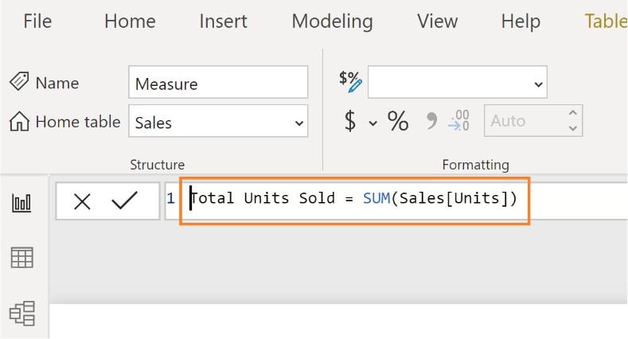

From the Measure tools ribbon select Format -> Whole number to format the measure

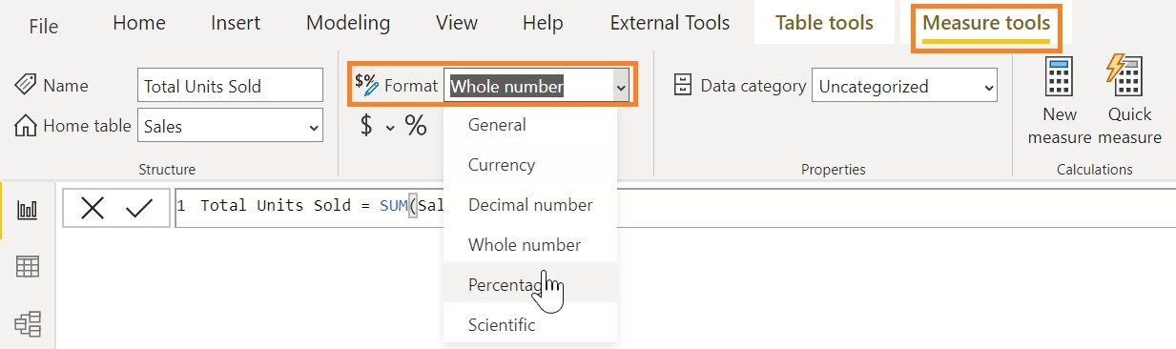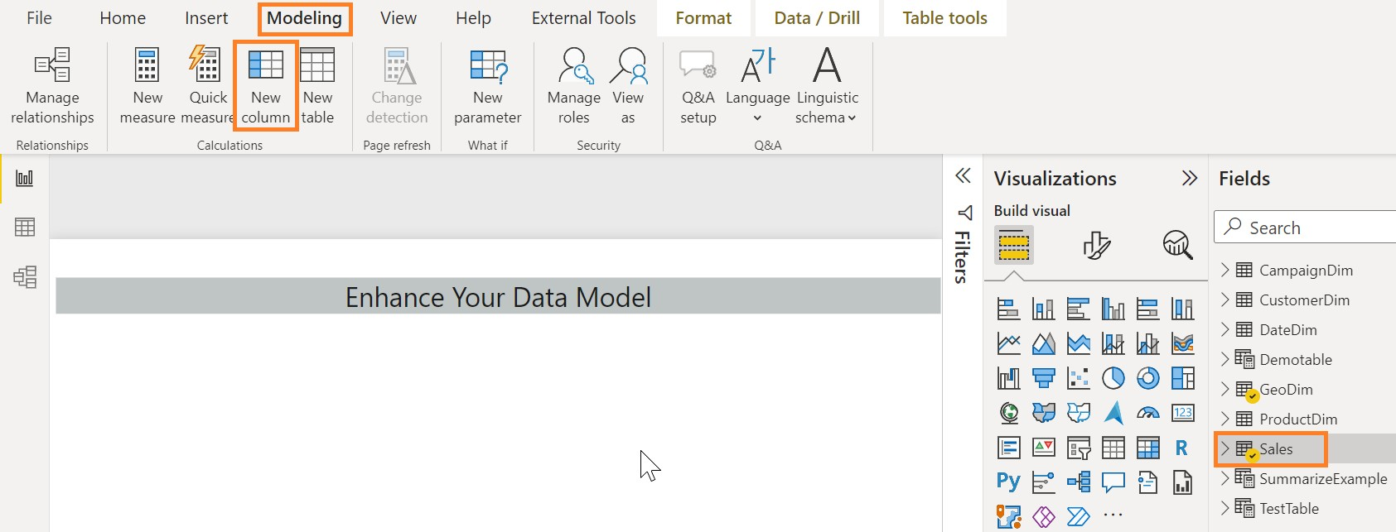

Task 2: Create calculated column that combines Category and TrafficChannel

Select Sales table. From the ribbon select Modeling -> New Column.

In the formula bar enter:

Category, Campaign = RELATED(ProductDim[Category]) & ", " & RELATED(CampaignDim[TrafficChannel])

Drag newly created Total Units Sold measure to the canvas. A clustered column chart is created

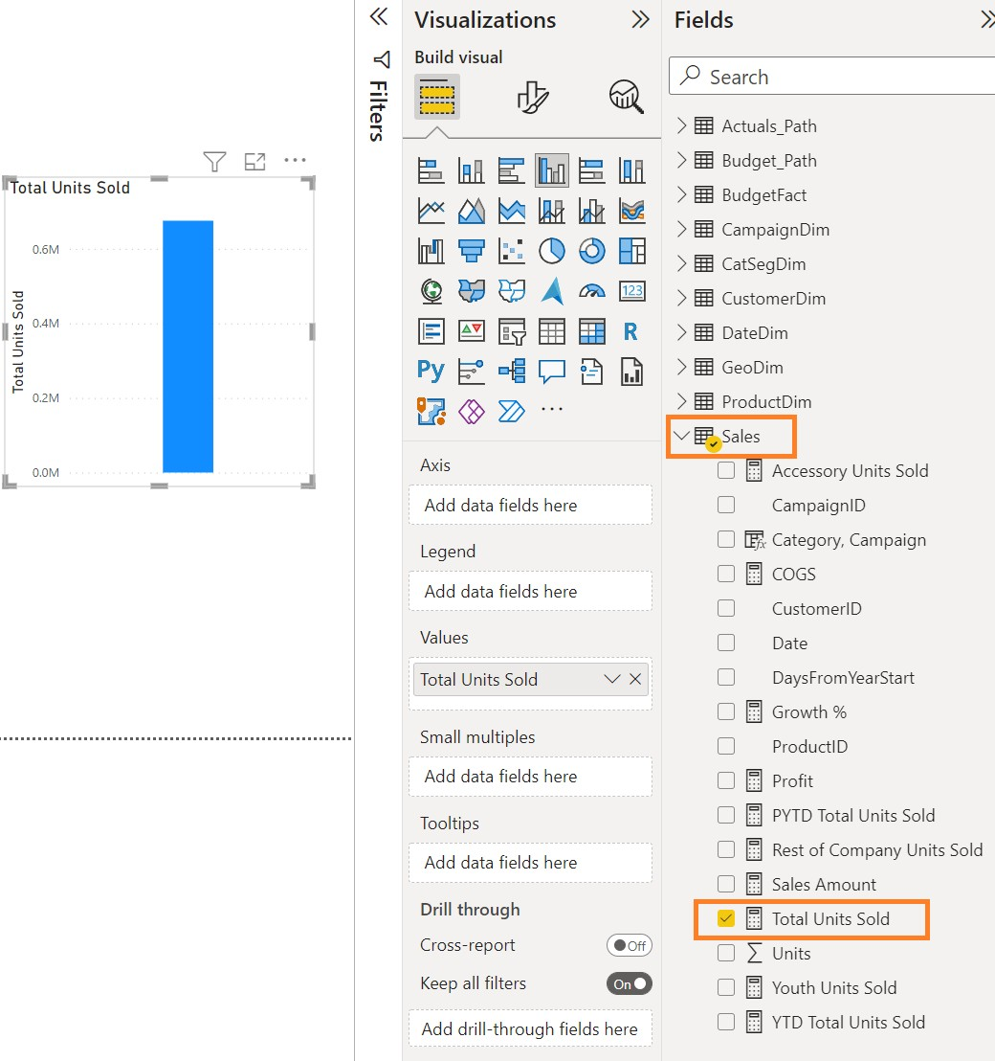

Drag Units field from Sales table to this visual

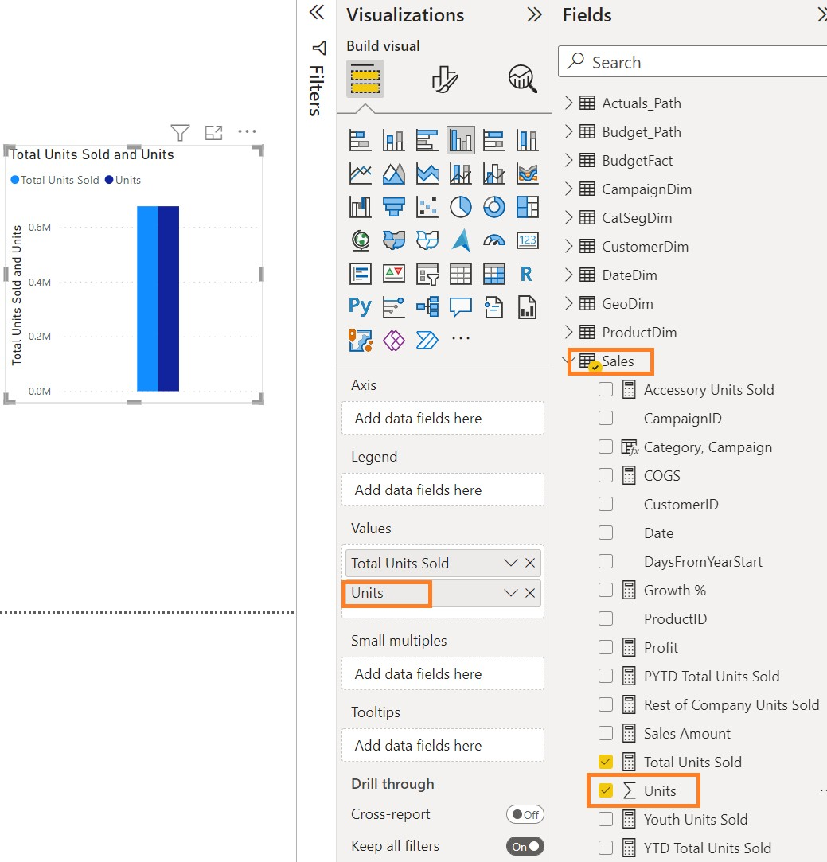

Select Device field from CampaignDim table

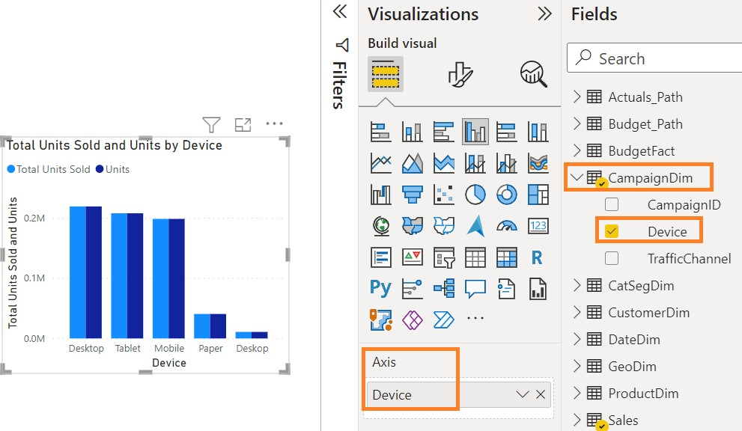

Lab 6: Create a report for the VP in charge of the Youth and Accessory Segments

Task 3: Create three new measures and a PowerBI visualization

The estimated time to complete this lab is 45 minutes.

Select Sales Table. From the ribbon select Modeling -> New Measure.

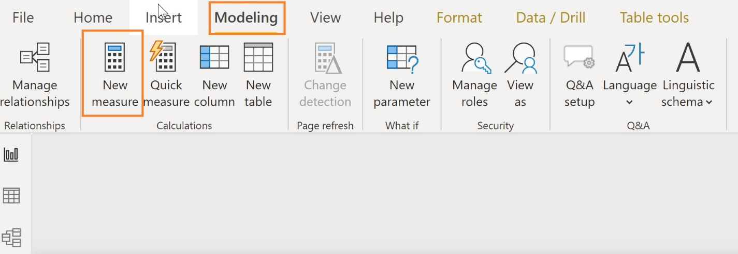

Create 3 measures:

Youth Units Sold = CALCULATE([Total Units Sold],FILTER(ProductDim,ProductDim[Segment]="Youth"))

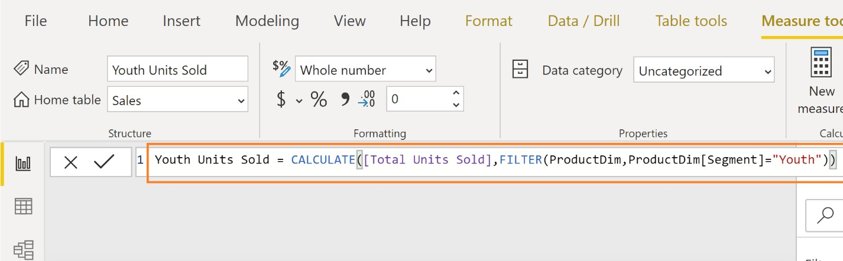

Accessory Units Sold = CALCULATE([Total Units sold],FILTER(ProductDim,ProductDim[Segment]="Accessory"))

Rest of Company Units Sold = CALCULATE([Total Units Sold],FILTER(ALL(ProductDim),AND(ProductDim[Segment]<>"Accessory",ProductDim[Se gment]<>"Youth")))

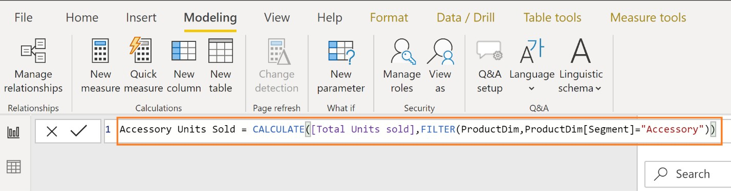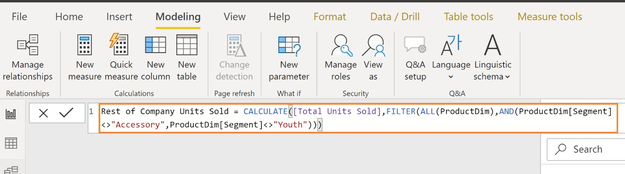

From the ribbon select Measure tools -> Whole Number and Comma to format the measure

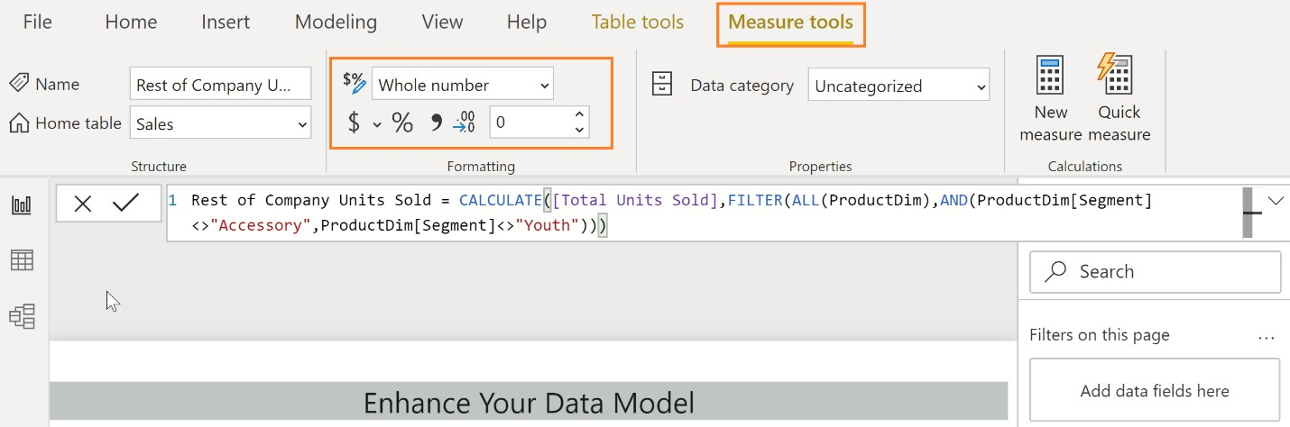

Add a table visual and drag CampaignDim -> Device and the 3 newly created measures

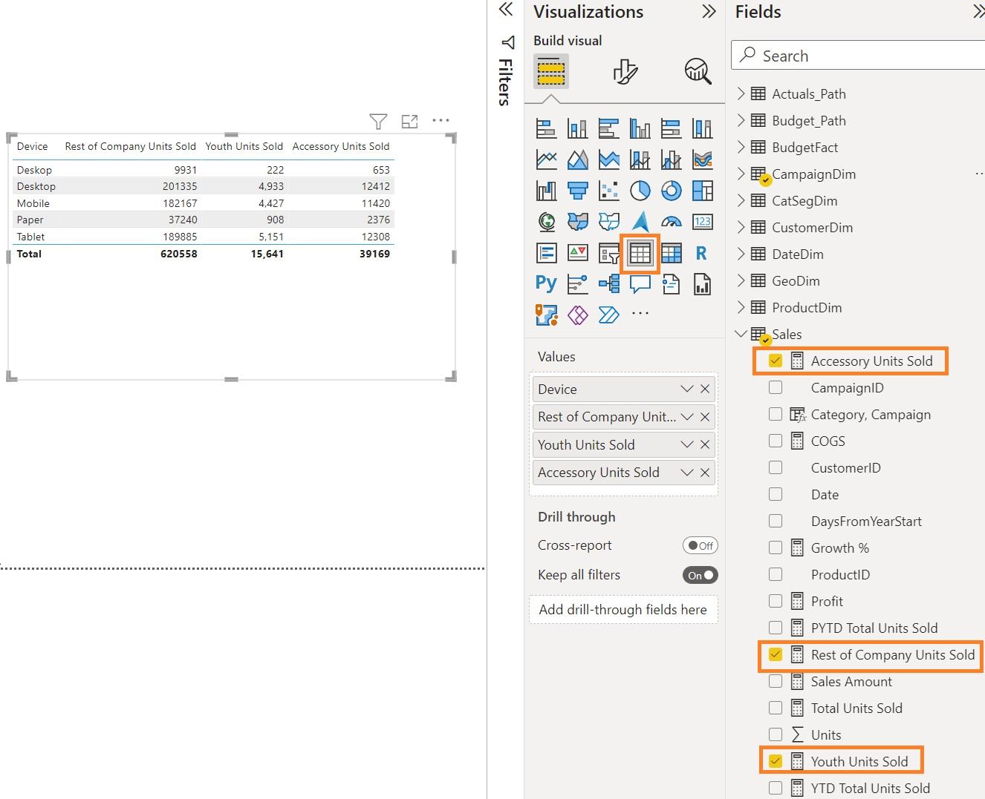

Select Line Chart visual.

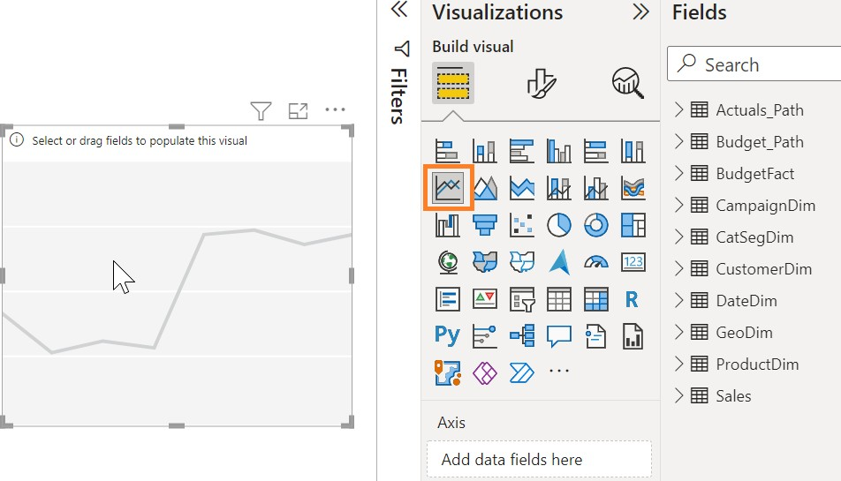

Select Date from Date table

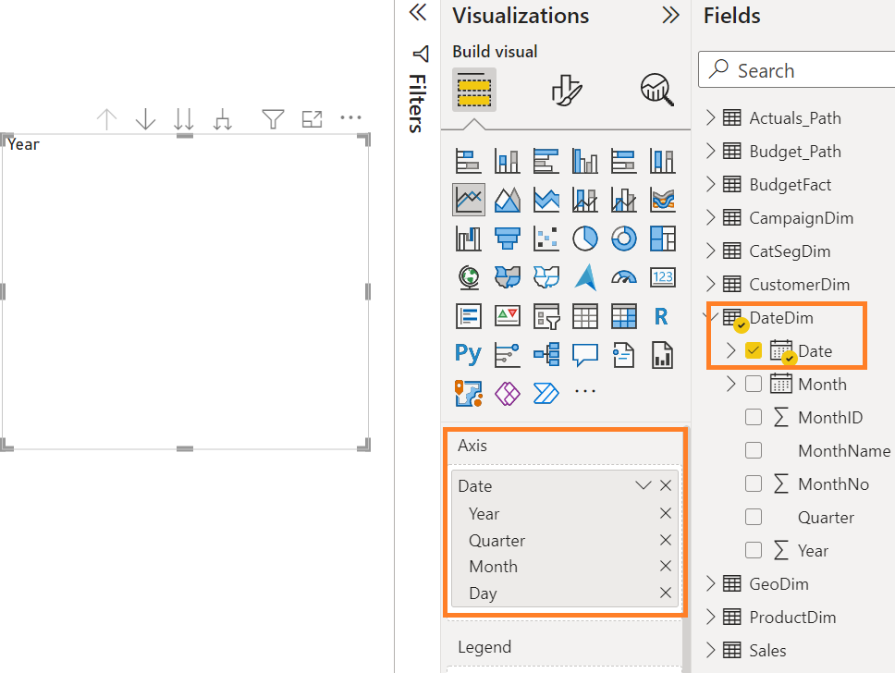

Select Youth Units Sold and Accessory Units sold measures.

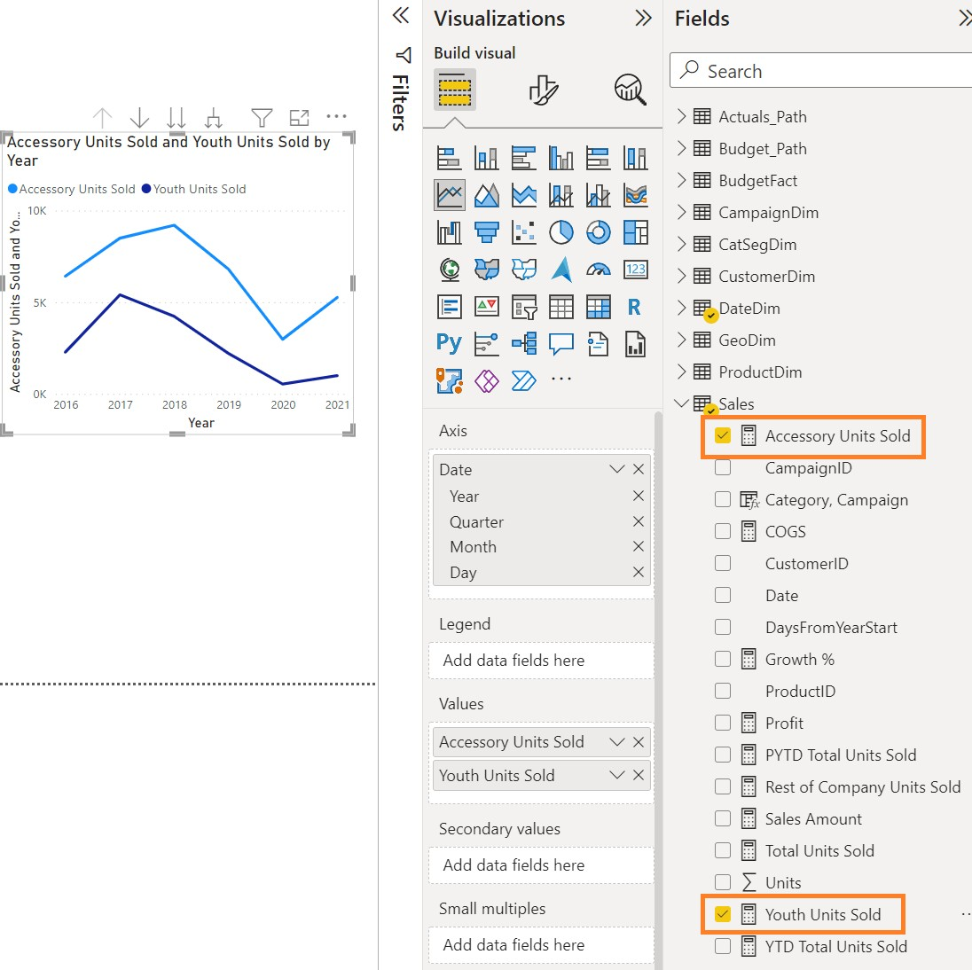

Create following measures and use a visual to analyze data.

COGS = SUMX(Sales, Sales[Units]) * RELATED(ProductDim[Unit Cost]))

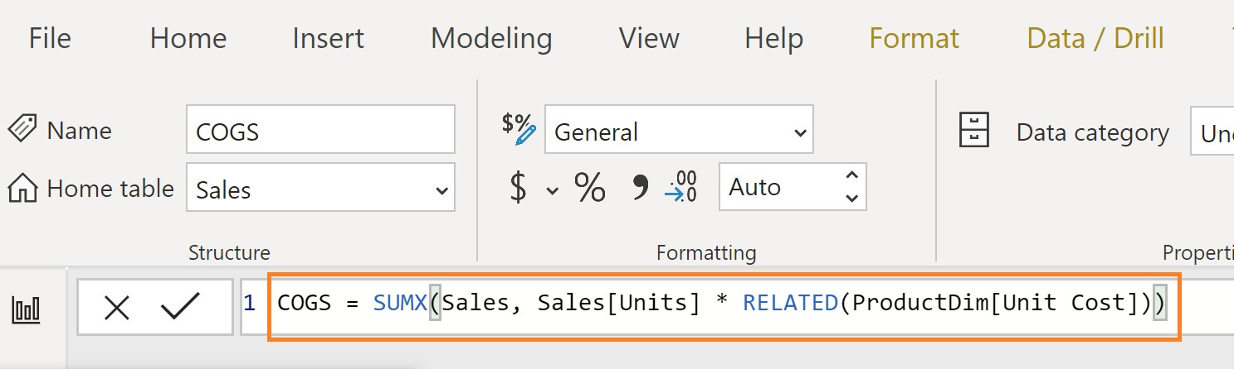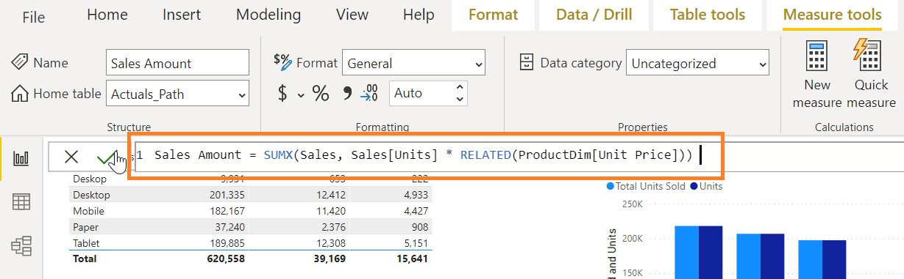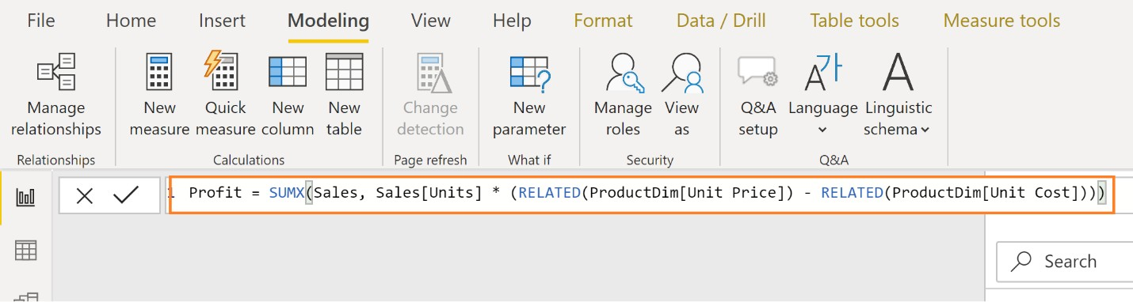

Sales Amount = SUMX(Sales, Sales[Units] * RELATED(ProductDim[Unit Price]))

Profit = SUMX(Sales, Sales[Units] * (RELATED(ProductDim[Unit Price]) - RELATED(ProductDim[Unit Cost])))

Lab 7a: Performance Best Practices

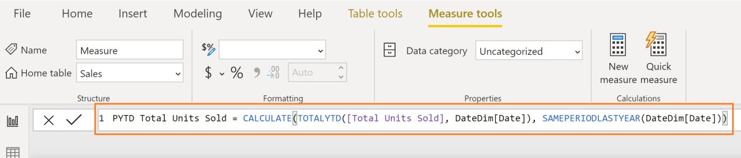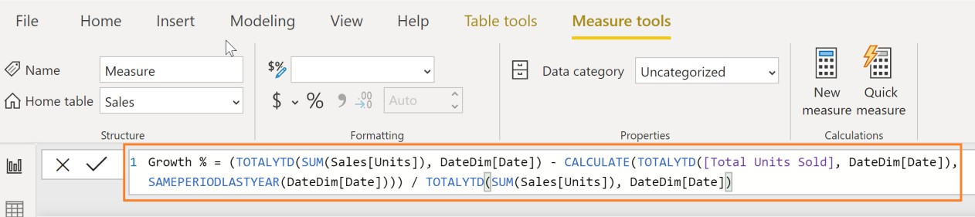

Task: Analyze DAX formulas to ensure you’re using the best practices

The estimated time to complete this lab is 30 minutes.

Create the three measures below.

YTD Total Units Sold = TOTALYTD(SUM(Sales[Units]), DateDim[Date])

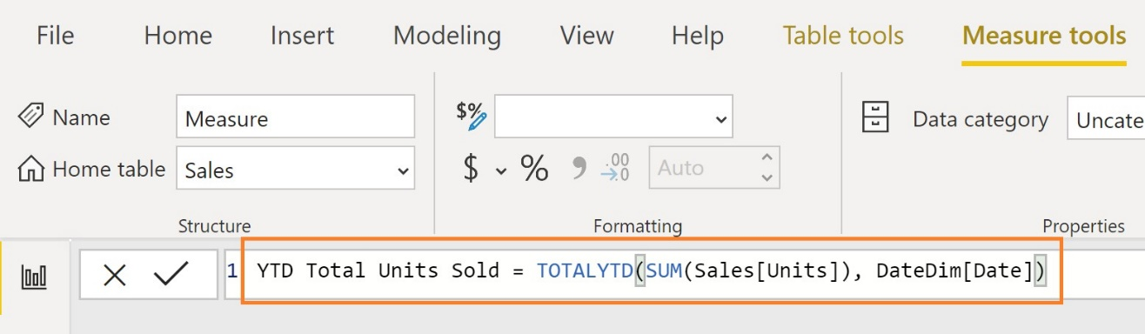

PYTD Total Units Sold = CALCULATE(TOTALYTD([Total Units Sold], DateDim[Date]), SAMEPERIODLASTYEAR(DateDim[Date]))

Growth % = (TOTALYTD(SUM(Sales[Units]), DateDim[Date]) - CALCULATE(TOTALYTD([Total Units Sold], DateDim[Date]), SAMEPERIODLASTYEAR(DateDim[Date]))) / TOTALYTD(SUM(Sales[Units]),

DateDim[Date])

Rewrite the DAX formulas to ensure performance best practices

YTD Total Units Sold = TOTALYTD([Total Units Sold], DateDim[Date])

PYTD Total Units Sold = CALCULATE([YTD Total Units Sold], SAMEPERIODLASTYEAR(DateDim[Date]))

Growth % = ([YTD Total Units Sold] – [PYTD Total Units Sold]) / [PYTD Total Units Sold]

Challenge: how were the formulas changed to increase performance?

Lab 7b: Using Performance Analyzer

Task: Use performance analyzer to test the performance of individual charts

The estimated time to complete this lab is 15 minutes.

Click on the View tab and open the Performance Analyzer

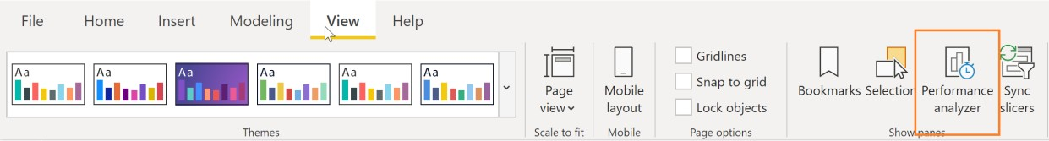

Start recording and click on Refresh visuals

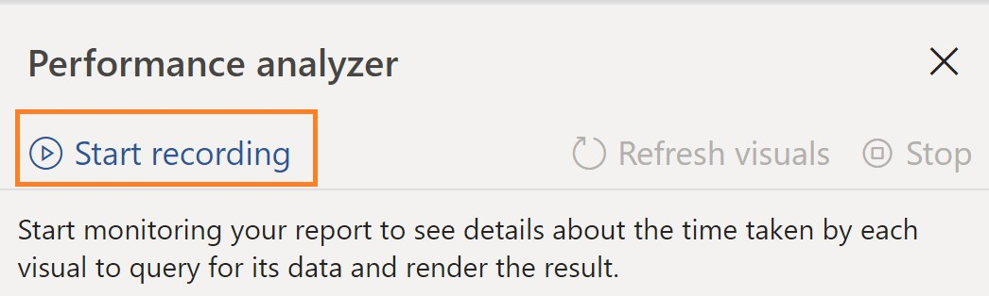

Analyze the data collected

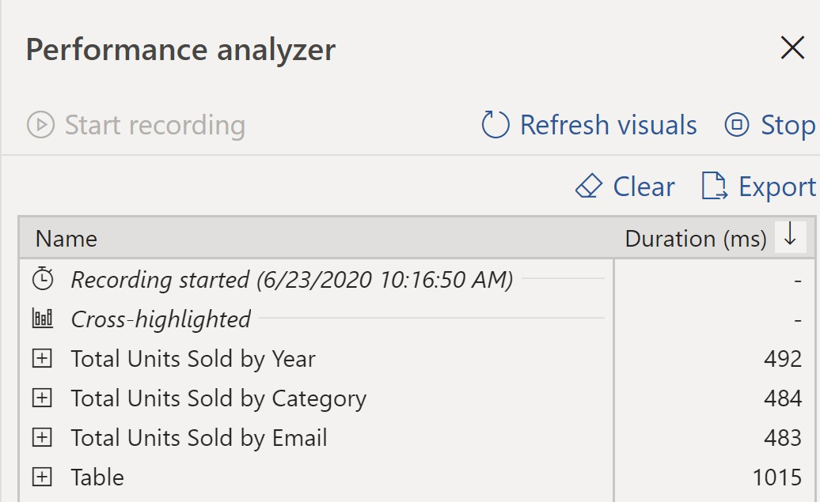

.

Challenge: What changes can you make to improve performance?

Summary

In this lab, you uploaded multiple tables from a single data source. You learned how to create a brand new dimension for the model as well as enhance existing dimensions. You will have created a new budget fact table for the model. In the end you will have created new parameters and dynamic paths to your data sources.

In this lab, you have also enhanced the model by adding additional measures and columns. In the end you will have tested the new measures and columns using Power BI data visualizations as well as worked with best practices and analyzed report performance.

Quorum Network Resources Limited  
18 Greenside Lane, Edinburgh, EH1 3AH

[www.qnrl.com](http://www.qnrl.com/) | [info@qnrl.com](mailto:info@qnrl.com)

Reg. No. SC 196645, Registered Office: 24a Melville Street, Edinburgh EH3 7NS.